<http://www.foodsafetynews.com/2012/04/2009-peanut-butter-outbreak-three-years-on-still-no-resolution-for-some/#.WrxPI4jwZPY>

<https://www.washingtonpost.com/news/to-your-health/wp/2015/11/03/major-foodborne-outbreaks-in-u-s-have-tripled-in-last-20-years/?utm_term=.9a8123f36328>

Key Points:

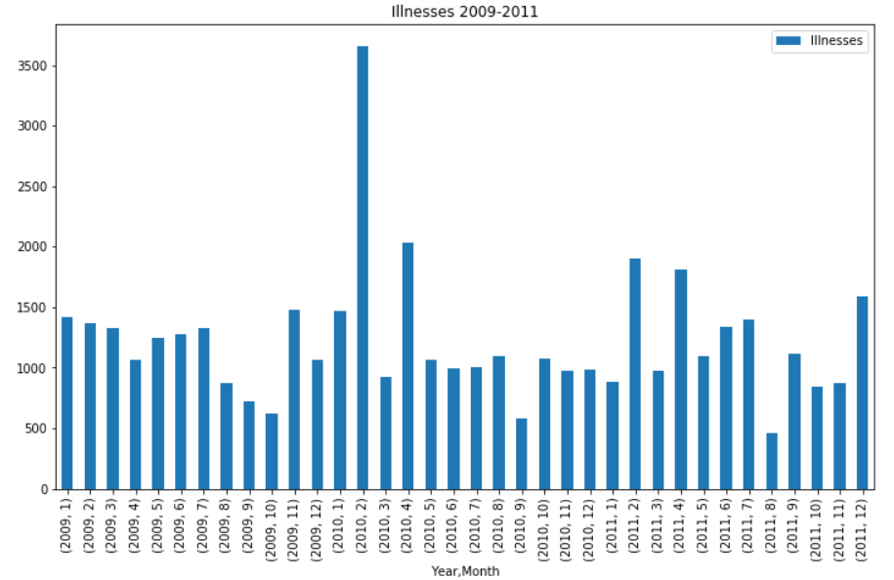

February 2010, spike in illnesses nearly double every other month between 2009 and 2011. Peanut butter outbreak.

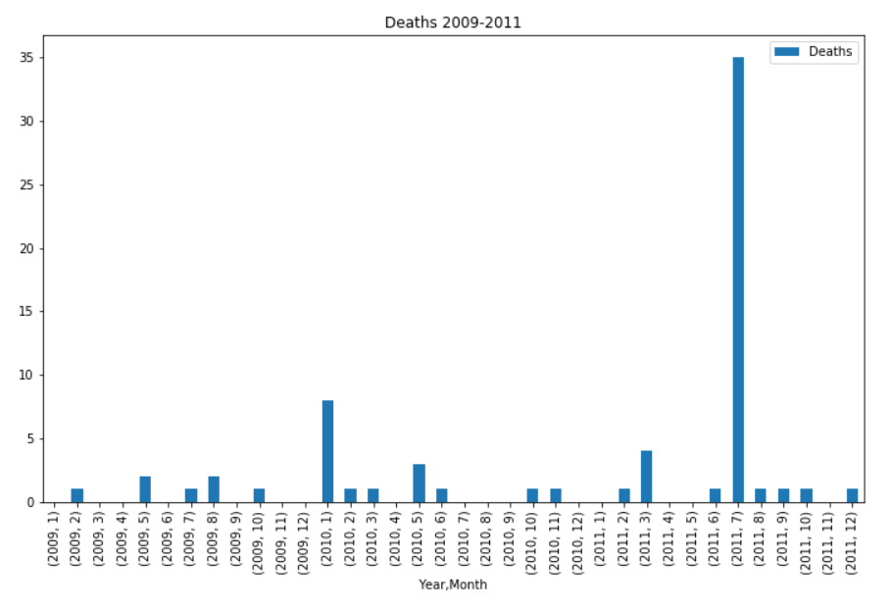

35 deaths in July 2011. “A sample of leftover unlabeled frozen ground turkey was collected by public health officials from the home of an ill person infected with the outbreak strain of Salmonella Heidelberg in Ohio. Culture of the ground turkey sample yielded the outbreak strain on July 29, 2011.”

<https://www.cdc.gov/salmonella/2011/ground-turkey-11-10-2011.html>

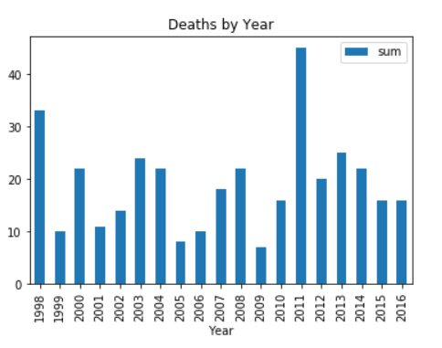

2011 had an outbreak of deaths which is the max of our data years, right after 2009 which was the minimum amount of deaths.